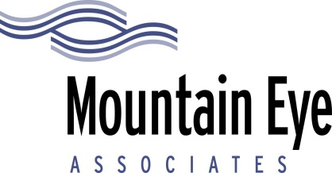

RELEASE OF MEDICAL RECORDS

DATE;_____________________________________________________________________________________________________________________

PATIENT NAME:_________________________________________________________________________________________________________

ADDRESS:_________________________________________________________________________________________________________________

______________________________________________________________________________________________________________________________

DATE OF BIRTH:_________________________________________________________________________________________________________

I hereby authorize Mountain Eye Associates, PLLC to release my entire medical record to:

__________________________________________________________________________________________________________

__________________________________________________________________________________________________________

___________________________________________________________________________________________________________

Patient or Legal Guardian Signature:_________________________________________________________________________________

Witness Signature:_______________________________________________________________________________________________________

486 Hospital Drive, Clyde, NC 28721 828.452.5816 800.522.3798 FAX 828.452.0373
65 Park Street, Canton, NC 28716 828.648.2483
1898 S. Main Street, Waynesville, NC 28786 828.456.2015

www.mountaineyeassociates.com
email mea@mountaineyeassociates.com
MEDICAL, SURGICAL, & CONSULTATIVE OPHTHALMOLOGY
Founded in 1977 by John J. Nerney, M.D.

David D. Markoff, M.D., F.A.C.S. Diplomate, American Board of 0phthalmology Stephen W. Hartzell, M.D., Ph.D.
Caroline L. Denwood, M.D. Eligible, American Board of Ophthalmology
Krislel W. Causby, O. D. Specializing in Family Vision Care & Contact Lenses Robert H. Dickey, O.D. Specializing in Family Vision Care & Contact Lenses

